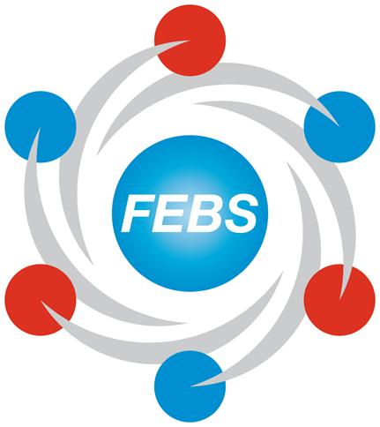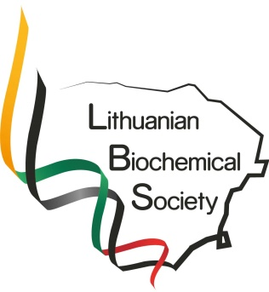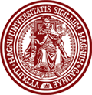
FEBS Workshop on Molecular Life Science Education
June 26-27th, 2017
Vytautas Magnus university, Putvinskio st. 23,
Kaunas, Lithuania

Hosted by the Lithuanian Society of Biochemistry (President: Daumantas Matulis)
Coordinators of Workshop:
Prof. Vida Mildaziene (Council of Lithuanian Society of Biochemistry),
Prof. Liliya Nadolnik (President of Belorussian Society of Biochemists and Molecular Biologists)

From FEBS Education Committee:
- Keith Elliott (Manchester, UK)
- Ferhan Sagin (Izmir, Turkey)
- Gül Güner Akdogan (Chair) (Izmir, Turkey)

Programme
Day 1: Monday, June 26th, 2017

08:30-09:15 | Registration
09:15- 09:30 | Welcome Address by Host |  | Vida Mildaziene
09:30-09:45 | FEBS Education Committee and Introduction to the Workshop |  | Gul Guner Akdogan
09:45-10:30 | Session 1: Panel Discussion:  Molecular Life Sciences Education in Lithuania and Key Knowledge and Skills for Molecular Life Sciences |  | Gervydas Dienys  Vida Midaziene
10:30-11:00 | Coffee
11:00-12:15 | Session 2: Student engagement and active learning: What are some best practices? How to choose & implement them? (open discusssion)  An example to active learning: Team-based learning |  | Ferhan Sagin
12:15-13:15 | Lunch
13:15-14:15 | Session 3: Biochemistry Practicals :  Introduction and Wet practicals |  | Keith Elliott
14:15-15:00 | Dry Practicals (Case-Based Discussions) |  | Gül Güner Akdoğan
 | Introduction to Small Group Discussions and Divide into Groups |  | Gul Guner Akdogan
15:00-17:00 | Small-Group Discussions ( Three Groups/ 40 min each)  (Rotation in three groups) (With Coffeee) |  | Keith/Gul/Ferhan
 | Wet/In Silico Practicals  Keith Elliott | Case Discussions  Gul Guner Akdogan | Team-based Learning  Ferhan Sagin
17:00-17:15 | General Discussion |  | FEBS Team
17:15-17:45 | Feedback of the day using questions organised in Kahoot |  | Gül Güner Akdogan
18:00 | Welcome Drinks
Day 2: Tuesday, June 27th, 2017

 | Session 4: PhD Training
09:00-09:45 | PhD Training: New Horizons |  | Gül Güner Akdogan
09:45-10:30 | Rethinking doctoral education’ (with a focus on student responsibility): 'Beginning with the end in Mind' |  | Ferhan Sagin
10:30-12:30 | Small-Group Discussions ( Three Groups/ 40 min each)  (Rotation in three groups) (With Coffeee) |  | Keith/Gul/Ferhan
 | - How to design PhD programmes?  Gül Güner Akdogan | 2. Quality of Thesis  Keith Elliott | 3. Tips for Writing a Research Paper  Ferhan Sagin
12:30-13:30 | Lunch
13:30-14:30 | Reports of Groups-General Discussion |  | FEBS Team
 | Session 5: Career Skills for Young Scientists
14:30-15:15 | Tips for Writing a Successful Research Project |  | Gül Güner Akdoğan
15:15-15:30 | Discussion
15:30-16:00 | Coffee break
16:00-16:45 | Funds and Programmes |  | Keith Elliott
16:45-17:00 | Discussion
17:00-17:30 | General Discussion, Feedback, and Closing of the Workshop |  | Gül Güner-Vida Mildaziene

